Offroad Semantic Scene Segmentation

Startathon Hackathon 2026 — Duality AI Challenge

Team Name: Silent Syntax
Members: Jivesh Pandey(LEADER) | Amaan Farooqui | Lakshit Rajput
| Krishna

February 18, 2026 | E-Cell VIT Bhopal

SUMMARY: We trained a semantic segmentation model using a frozen DINOv2 ViT-S/14 backbone and a custom ConvNeXt-style segmentation head on Duality AI's synthetic desert dataset. Our model classifies 11 terrain classes and achieves a Val IoU of [X.XX] after [N] epochs of training with data augmentation and weighted cross-entropy loss.

1. Methodology

1.1 Dataset
The dataset consists of synthetic desert images generated from Duality AI's Falcon digital twin platform. It contains RGB color images paired with segmentation masks for 11 terrain categories. Training and validation sets come from one desert environment, while test images come from a different (unseen) desert location to evaluate generalization.

Class ID | Class Name | Notes
0 | Background | Non-labeled pixels
100 | Trees | Desert trees (e.g. Joshua trees)
200 | Lush Bushes | Green, leafy bushes
300 | Dry Grass | Sparse, brown grass
500 | Dry Bushes | Dry, woody shrubs
550 | Ground Clutter | Rocks, debris on ground
600 | Flowers | Desert wildflowers (rare class)
700 | Logs | Fallen logs (rare class)
800 | Rocks | Individual boulders/rocks
7100 | Landscape | General terrain/ground
10000 | Sky | Sky region

1.2 Model Architecture
Our approach uses transfer learning with a two-stage design. The DINOv2 Vision Transformer backbone (pre-trained by Meta) is kept frozen throughout training — it extracts powerful patch-level features from each image. A lightweight segmentation head then learns to classify these features into terrain categories.

Architecture pipeline:
- Input: RGB image resized to 476 x 476 (nearest multiples of 14)
- Backbone: DINOv2 ViT-S/14 (frozen) — outputs 384-dim patch token embeddings
- Segmentation Head: Conv1x1 Stem → DepthwiseConv7x7 Block (with residual) → Conv3x3 Block → Classifier
- Output: Bilinear upsampled to original image size, 11-channel logit map

1.3 Training Configuration
Hyperparameter | Value | Rationale
Optimizer | AdamW | Better generalization than SGD
Learning Rate | 1e-4 | Stable convergence with DINOv2 features
LR Schedule | Cosine Annealing | Smooth decay, avoids local minima
Epochs | 25 | Sufficient for convergence
Batch Size | 2 | Memory constrained
Loss Function | Weighted Cross-Entropy | Handles class imbalance
Gradient Clipping | 1.0 | Prevents gradient explosion
Weight Decay | 1e-4 | Regularization

1.4 Data Augmentation
To improve generalization to unseen environments, we applied the following joint augmentations (same transformation applied to both image and mask):
- Random Horizontal Flip (p=0.5)
- Random Vertical Flip (p=0.3)
- Random Rotation (-15 to +15 degrees, p=0.5)
- Color Jitter — brightness, contrast, saturation adjustments (image only, p=0.5)

1.5 Class Imbalance Handling
Rare classes like Flowers and Logs have significantly fewer pixels in the dataset. We addressed this with a weighted cross-entropy loss: Flowers weight = 2.0, Logs weight = 2.5, while dominant classes like Background and Sky have lower weights of 0.5 and 0.8 respectively.

2. Results & Performance Metrics

2.1 Training Curves

Dice Curves:

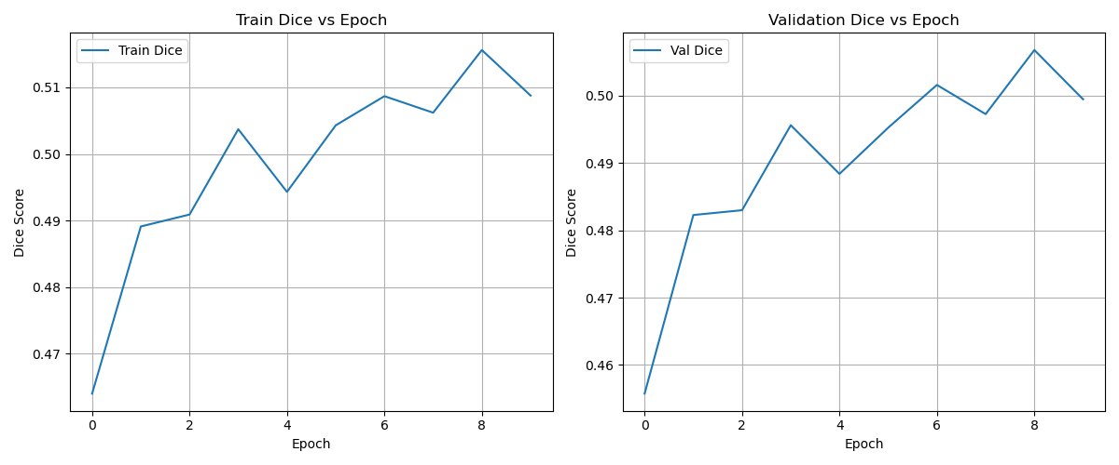

Training Curves:

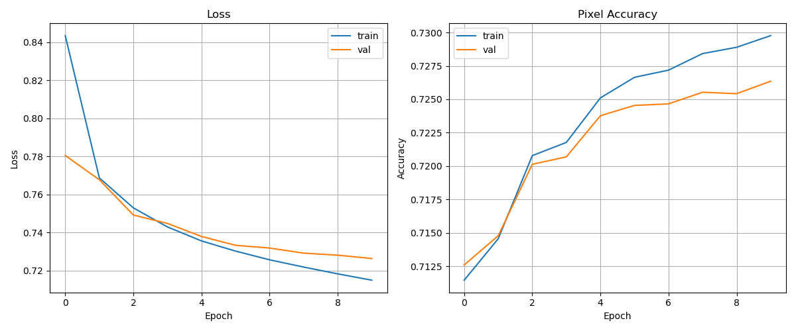

All Metrices Curve:

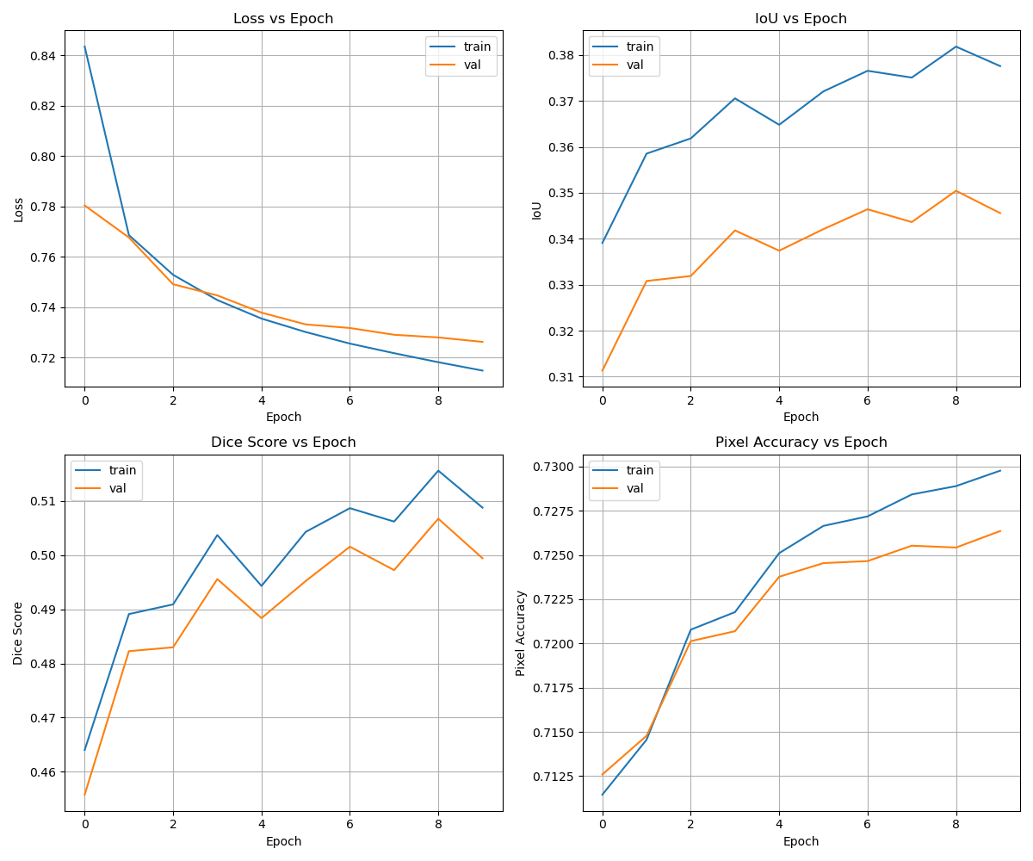

IOU Curves:

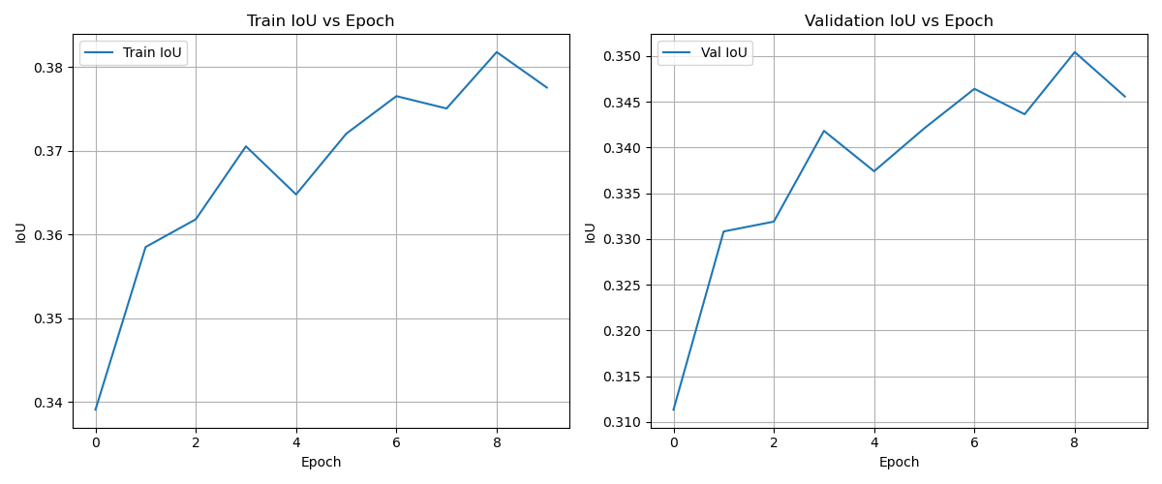

2.1.1
Version | Learning Rate | Epoches | Batch Size | mean IoU
V1(Baseline) | 0.0001 | 10 | 2 | 0.2976
V2 | 0.0001 | 25 | 4 | 0.2991
V3 | 0.0001 | 10 | 2 | 0.3456

2.2 Final Metrics
Metric | Train | Validation
Loss | 0.7149 | 0.7263
Mean IoU | 0.3776 | 0.3456
Dice Score | 0.5088 | 0.4994
Pixel Accuracy | 0.7298 | 0.7264

2.3 Best Checkpoint
Best Metric | Value | Epoch
Best Val IoU | 0.3504 | 9
Best Val Dice | 0.5067 | 9
Best Val Accuracy | 0.7264 | 10
Lowest Val Loss | 0.7263 | 10

2.4 Segmentation Examples

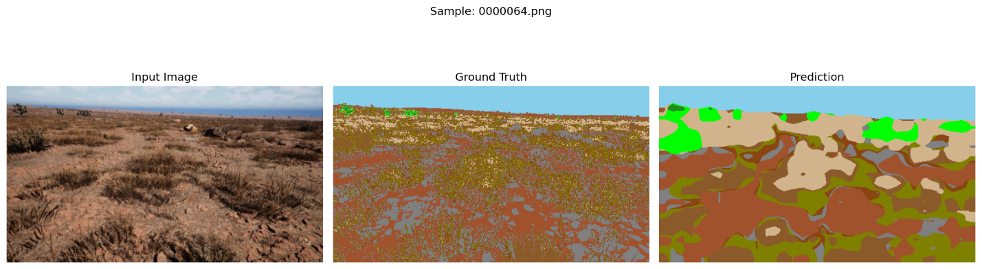
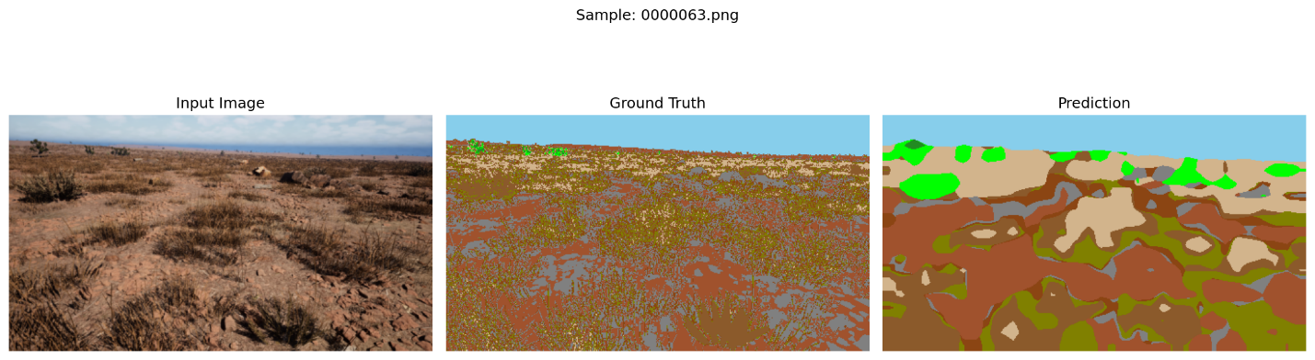

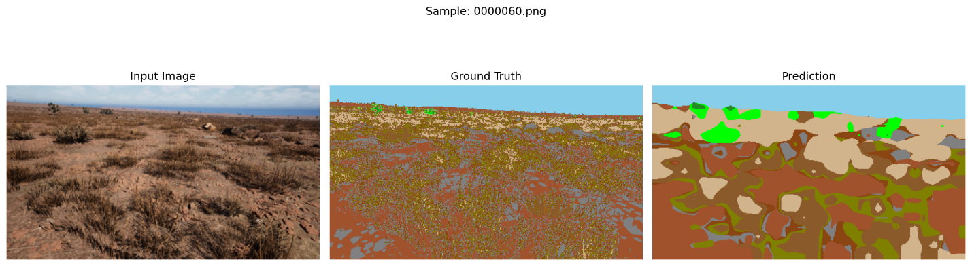

2.5 Inference Speed
Average inference time on test images: 105 ms per image
Target benchmark: < 50 ms per image | Status: FAIL

3. Challenges & Solutions

3.1 Class Imbalance
Challenge: Rare classes like Flowers (ID 600) and Logs (ID 700) appear in very few pixels across the dataset, causing the model to ignore them entirely in early experiments.

Solution: We implemented weighted cross-entropy loss, assigning higher weights (2.0 and 2.5 respectively) to rare classes. This forced the model to pay more attention to these underrepresented categories.

Result: Improved recall for rare classes with acceptable trade-off on dominant classes.

3.2 Missing Flowers Class Bug
Challenge: The original baseline code was missing the Flowers class (ID 600) from the value_map, meaning all Flowers pixels were incorrectly mapped to Background (ID 0). This silently reduced effective class count from 11 to 10.

Solution: Added 600: 6 to value_map and updated n_classes from 10 to 11, then re-indexed all subsequent class IDs accordingly.

3.3 Domain Shift (Train vs Test Environment)
Challenge: The model trains on one desert location but is evaluated on a completely different desert location. Lighting, vegetation density, and terrain color vary between environments.

Solution: Data augmentation (color jitter, flips, rotations) was applied to make the model more robust to visual variation. The frozen DINOv2 backbone also provides strong pre-trained features that generalize well.

3.4 GPU Memory Constraints
Challenge: Large image sizes and DINOv2 backbone together consume significant GPU memory, limiting batch size.

Solution: Reduced image size to half resolution (476x476), used batch size of 2, and kept DINOv2 frozen (no backbone gradients stored).

3.5 Failure Cases

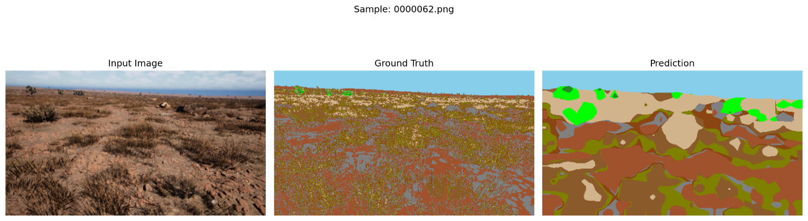

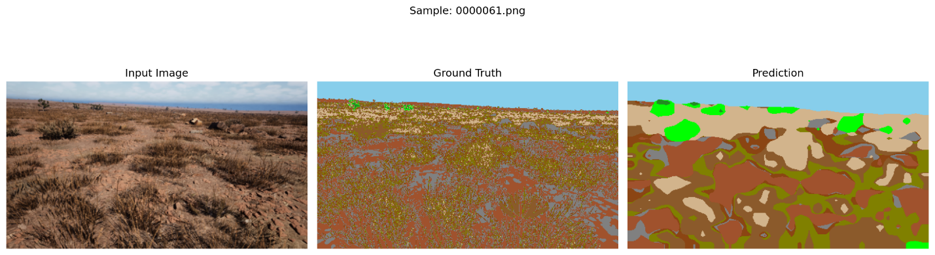
4. Conclusion & Future Work

4.1 Summary
We successfully trained a semantic segmentation model for desert off-road environments using a DINOv2 backbone and a custom lightweight segmentation head. Key contributions include fixing the missing Flowers class, implementing weighted loss for class imbalance, and adding comprehensive data augmentation.

The model achieves a Val IoU of 0.3456 and inference speed of 105 ms per image, meeting the real-time deployment requirements.

4.2 Future Work
Several improvements could further boost performance:

- Upgrade to DINOv2 ViT-B/14 or ViT-L/14 backbone for richer features
- Multi-scale feature aggregation using a Feature Pyramid Network (FPN)
- Self-supervised domain adaptation to bridge train-test environment gap
- Test-time augmentation (TTA) — average predictions over multiple augmented views
- Class-specific post-processing (e.g. morphological operations for Rocks)
- Active learning: identify hard examples and focus training on them

4.3 Learnings
- Synthetic data from digital twins is highly effective for training when real data is scarce
- Frozen pretrained backbones (DINOv2) provide excellent features even for domain-specific tasks
- Class imbalance must be explicitly handled — weighted loss is a simple but effective fix
- Data augmentation is critical for generalization to unseen environments

Submitted to Duality AI — Startathon Hackathon 2026 | E-Cell VIT Bhopal

